Course Name | ITD 2343 – Object Oriented Programming with C#
Instructor | Mark L. Pranger
Student Name | Eric Christensen
Due date | Oct 1, 2025
Grade | <grade earned here>
Grading Comments | <instructor comments here>

Week 4 – Programming Lab

Screen Shots needed for Submission:
- Show the code for the buttons in as few screen shots as possible

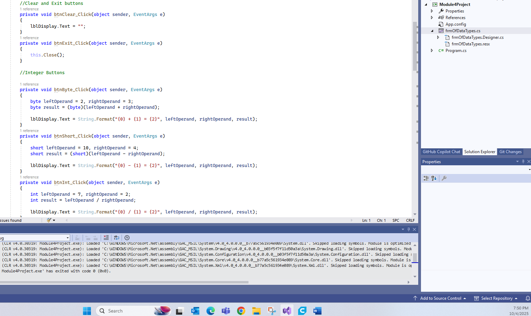

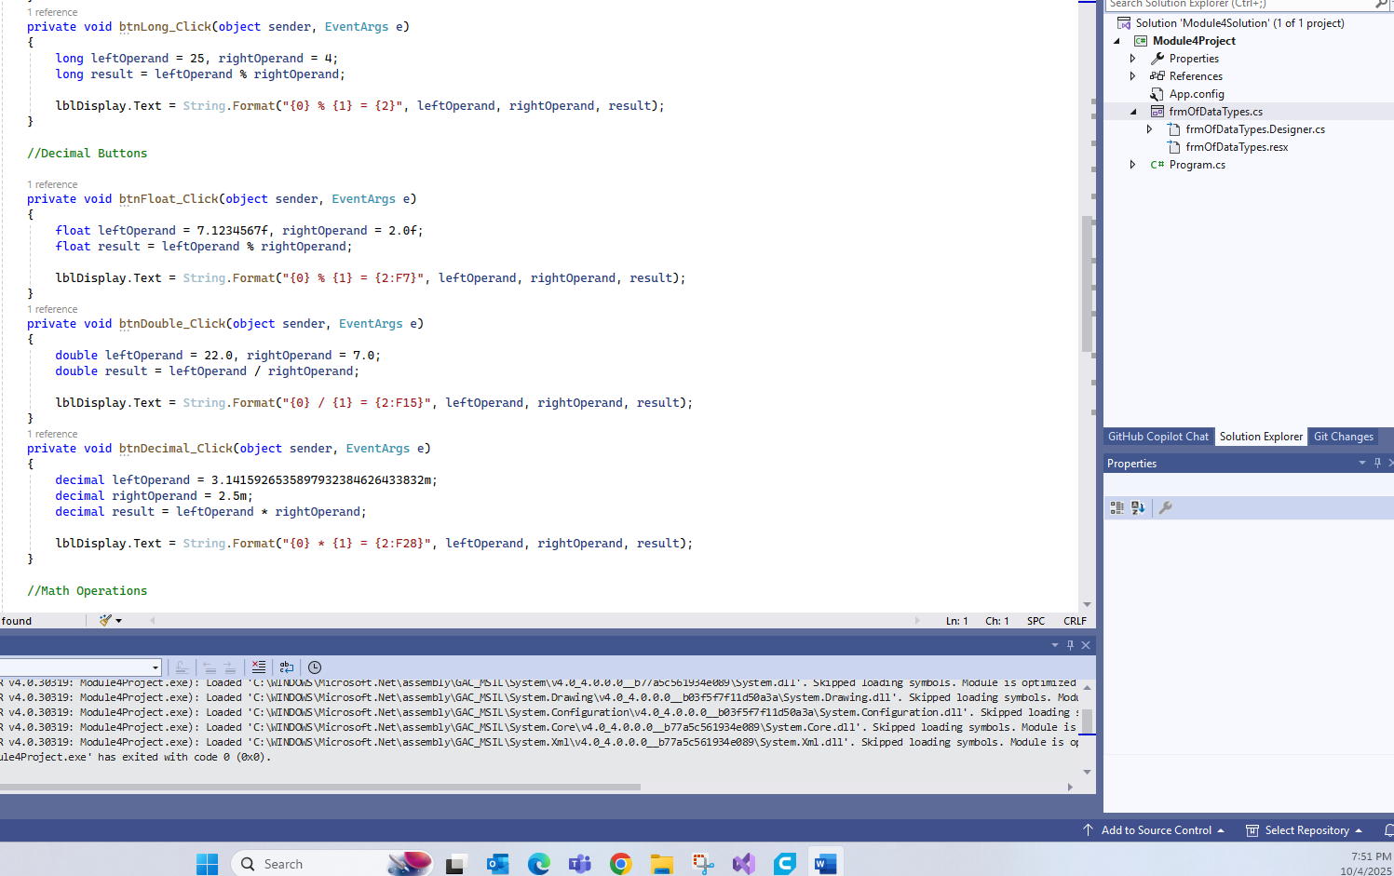

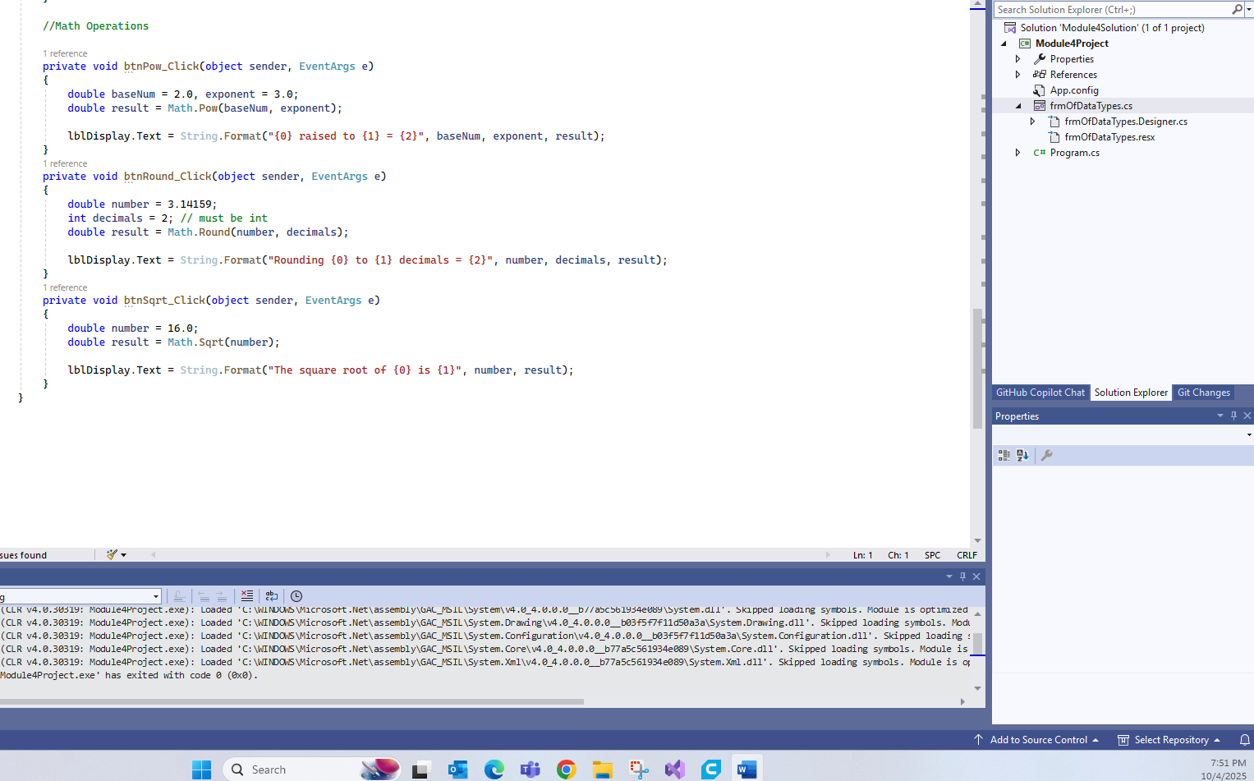

- Run the application in debug mode, screen shot the whole screen showing the form starting up in the center
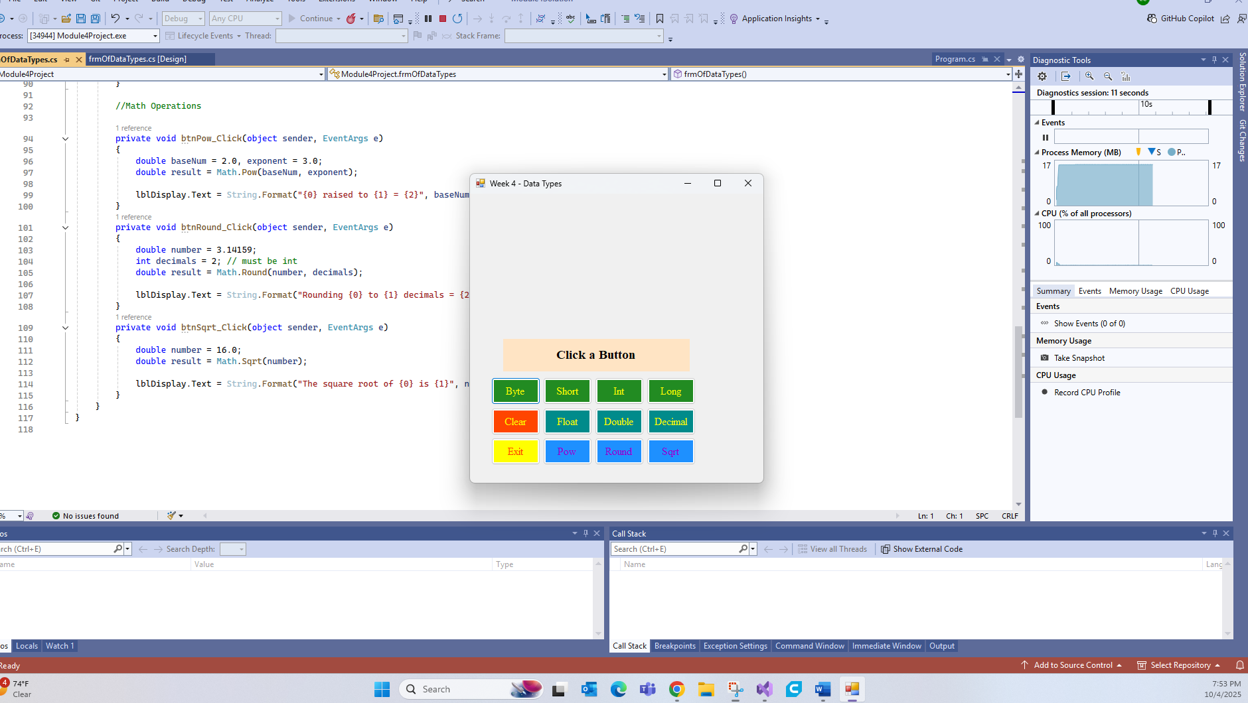

- Screen shot the results of each of the buttons except the Clear and Exit buttons.

Byte –
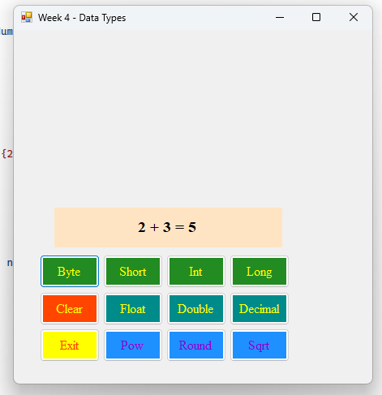

Short –
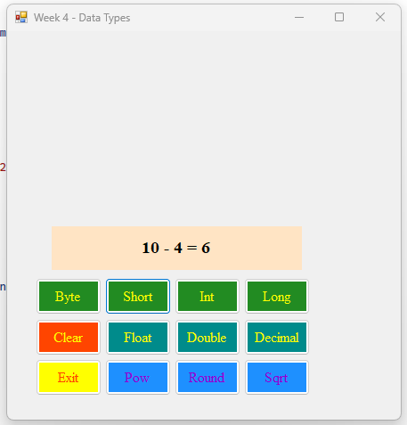

Int –
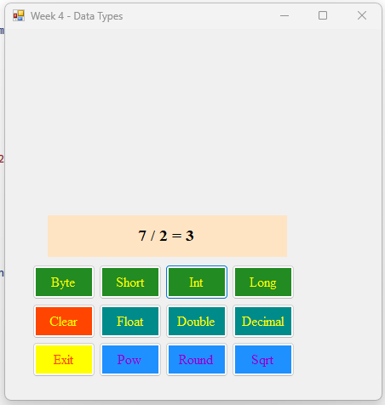

Long –
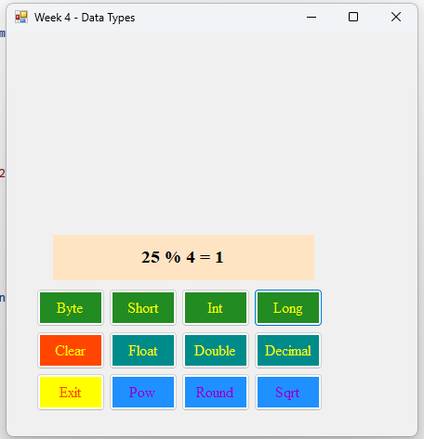

Float –
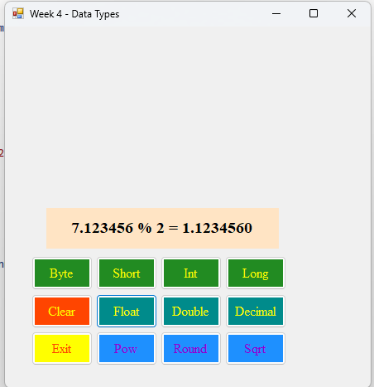

Double –
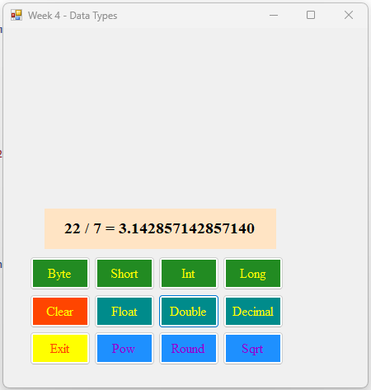

Decimal –
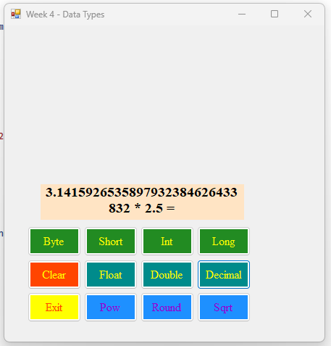

Pow –
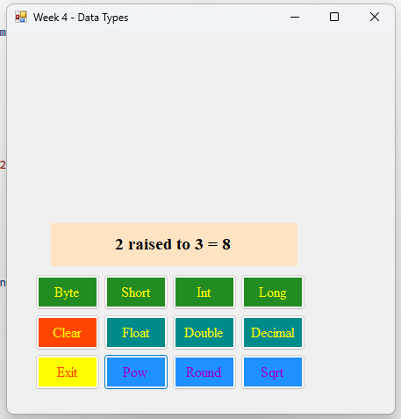

Round –
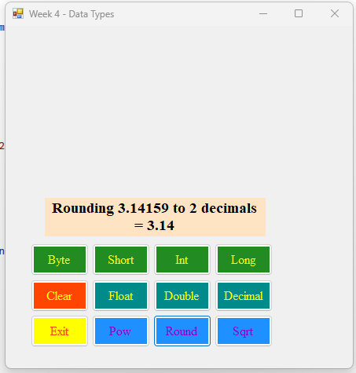

Sqrt –
